

**Sign up Now !!!**

******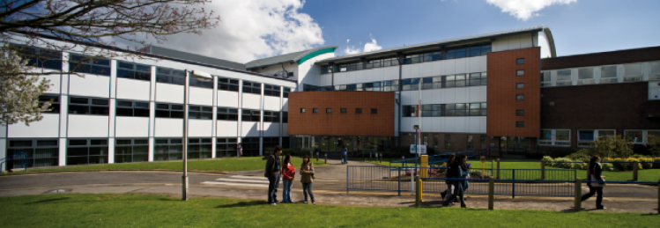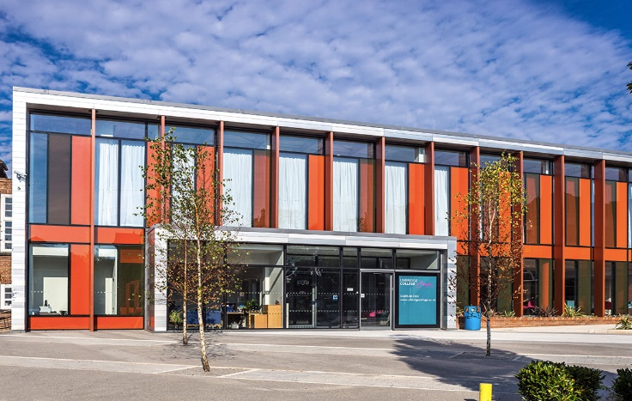

**UXBRIDGE.AC.UK/OPENDAYSYYYYSYS**

***OPEN DAY***

@ HAYES CAMPUS

ON

8TH NOVEMBER 2018

FROM 3 – 7 PM

@ UXBRIDGE CAMPUS

ON

6TH NOVEMBER 2018

FROM 3 – 8 PM



Uxbridge

Campus

In Hayes

UB3 3BB

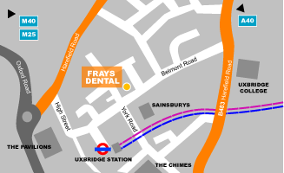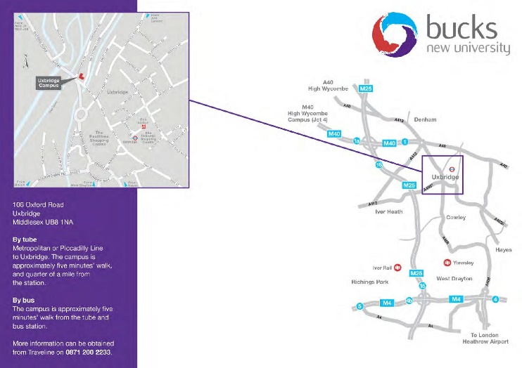******

**Sign up**

**Now !!!**

Also feel free to Contact us @

Email : Uxbride.ac.uk/openday

Tel: 01895 853333

Uxbridge

College

UB8 1NQ